IN Liugong UAT Manage Employee Details Screen defects

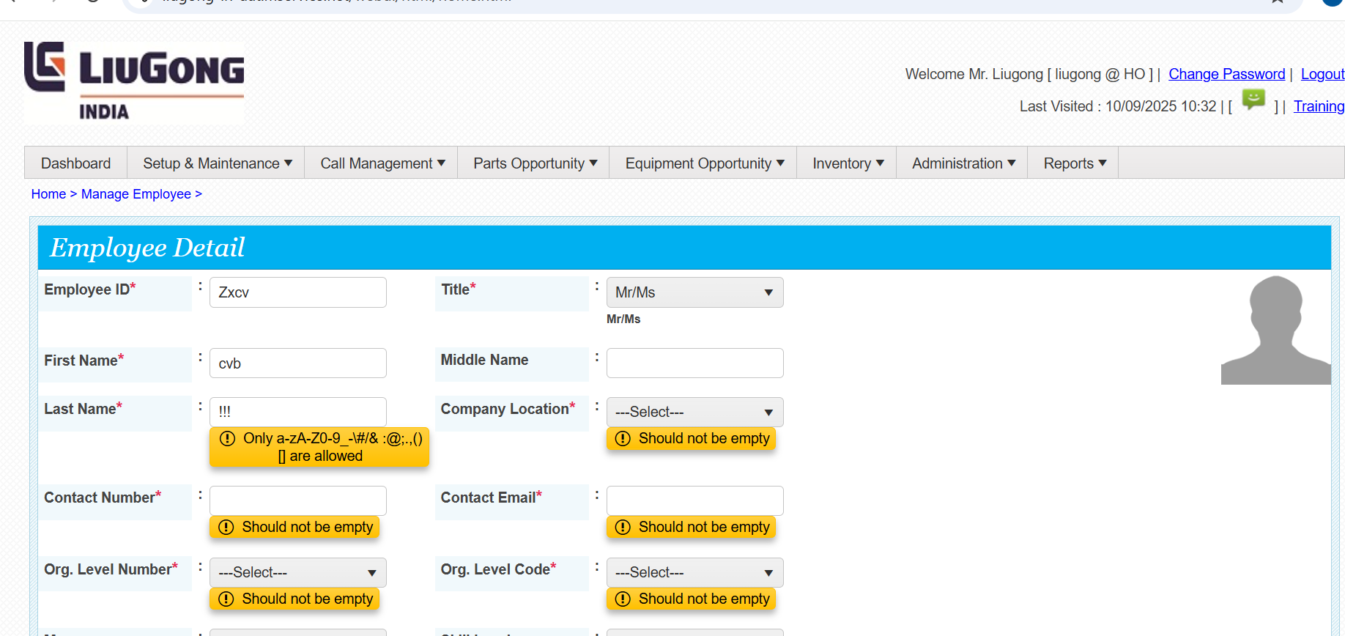

As per the Liugong UAT, on the Employee page certain requirements were mentioned. However, when entering input into the widgets, they are not functioning properly.(defect occurs)

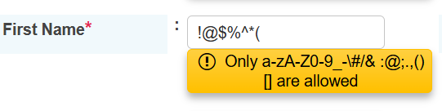

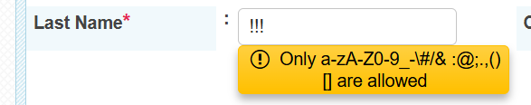
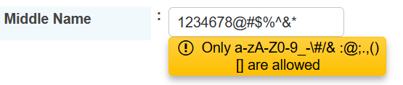

The above widgets are designed to accept only valid inputs as mentioned in the requirements."

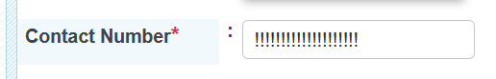
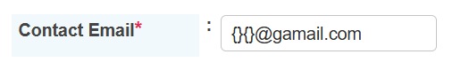
First Name:
Below, I have mentioned both the requirement and the defects observed, where the widgets are incorrectly accepting invalid inputs
Requirements : Only a-zA-Z0-9_-\#/& :@;.,()[] are allowed.
Defect : $ % *_ - + . This all are also accepted

Last Name:
Requirements : Only a-zA-Z0-9_-\#/& :@;.,()[] are allowed
Defect : $ % *_ - + . This all are also accepted.
Middle Name:
Requirement : Only a-zA-Z0-9_-\#/& :@;.,()[] are allowed
Defect : $ % & * _ - + . This all are also accepted.
Contact Number :
- In the Contact Number field, the system is accepting alphabets and special characters.
- The Contact Number field is not restricted to a minimum valid length.
- The Contact Number field is currently accepting more than 20 digits.
Contact Email :
In the Contact Email field, the system is accepting invalid formats such as text before ‘@gmail.com’, which should not be allowed.: !#$%^&*_-+|{}’

When I enter invalid data and submit, the page gets submitted without showing any error or alert message.

